Visualization 1:

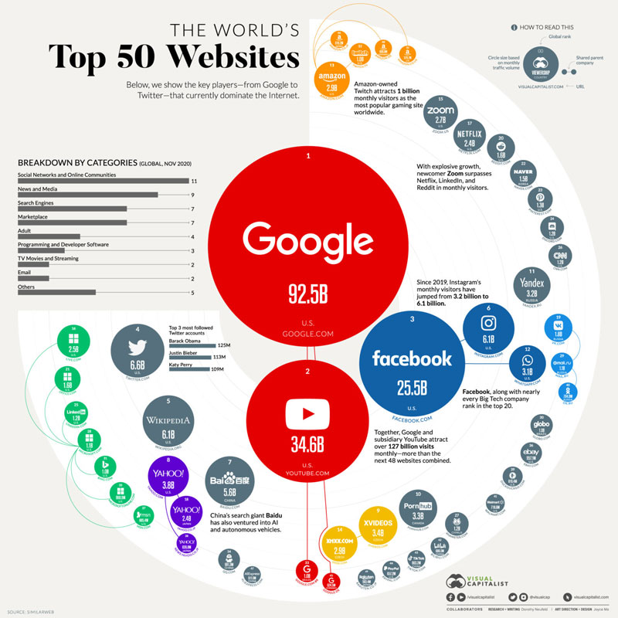

This chart is meant to convey the number of views each website has and display the ones with the most views as the largest/least as smallest bubbles. While this idea seems good in theory, the data could be visualized in a better way; i.e. a bar graph.

The bubbles on the bubble chart are only readable when big. Only the three biggest bubbles are readable, after that they become very hard to read.

The colors on the data visualization are good, they illustrate the company and the subsidiaries of the company. It makes it clear which are interconnected. We can easily see that google and its subsidiary YouTube have the biggest overall presence on the internet.

This chart can be found on a website all about data visualizations. We can assume the audience would be mostly people who like to look at data visualizations instead of news articles. I think this is trying to tailor towards them but it does not do a good job. This is because the chart is hard to read.

The white space of the visualization is well balanced. All of the space is filled without being too full.

Overall this visualization has all of the components of a good one, it just lacks the right format for the main section. Making it so hard to read everything with less visits than Facebook is ineffective. It’s unfortunate that they chose this format over other more clear ones.

Source: <https://www.visualcapitalist.com/the-50-most-visited-websites-in-the-world/>

Visualization 2:

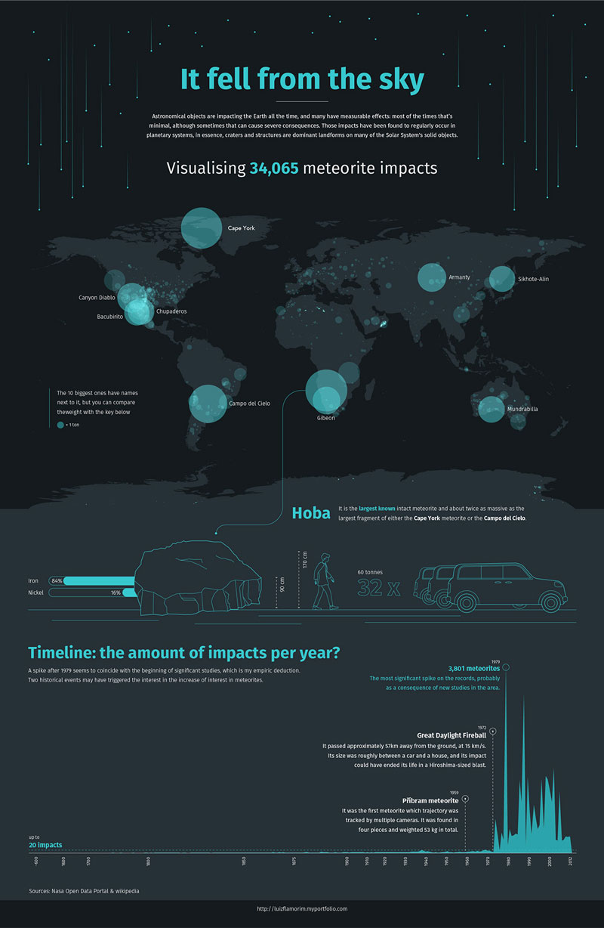

This is an example of a good visualization. It is easy to read, understand, and tells a story. Part of the reason it is so easy to look at is the use of the space. There is a good spread between each part of the graph.

The graph itself is easy to see. The creator is trying to highlight where on earth the biggest meteors fall and where they fall in general. He highlights some of the biggest ones using their names, size, and opacity of the circle.

The graph on the bottom does a good job at highlighting big events regarding meteors in history by circling them and giving some details about them. These could be showers or just one big meteor.

There is not a specific audience the creator has in mind as this was a project done for fun. Anyone can look at this visualization and immediately see where the biggest/most meteors fall on the planet as well as a little history at the bottom.

Lastly he makes it easy to compare the size of the bigger meteors to object we are familiar. This gives us better understanding of the relative size of each meteor that fell.

Source: <https://www.behance.net/gallery/95352539/It-Fell-from-the-Sky>

Visualization 3:

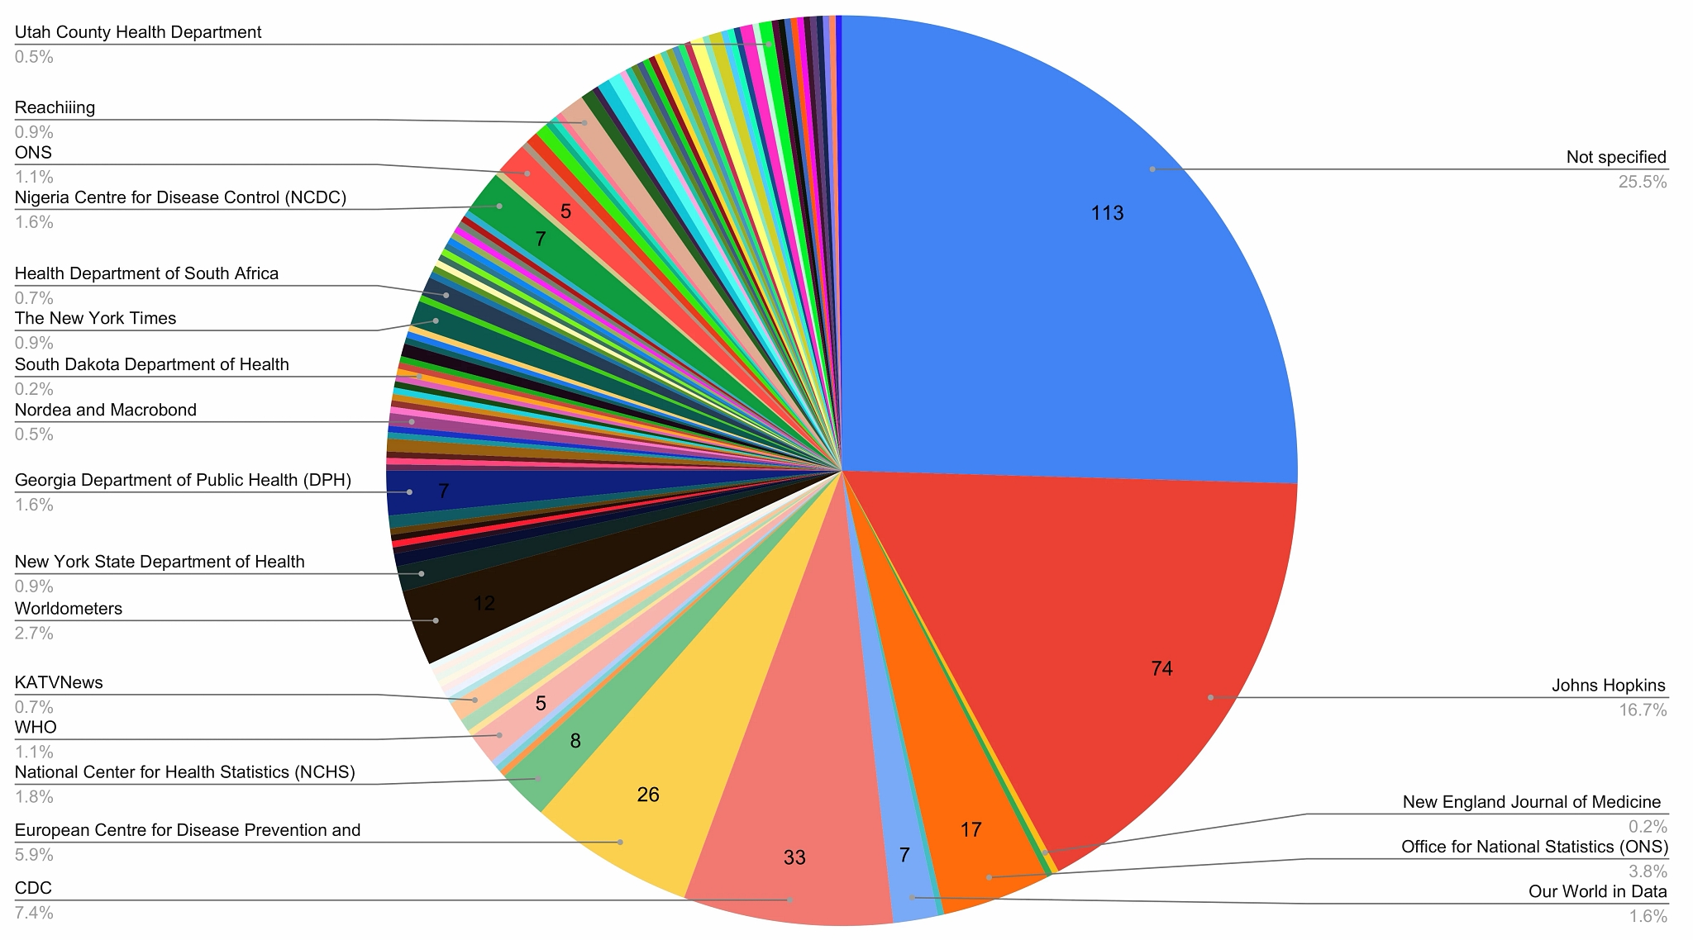

This is a pie chart showing the number of times the entity was cited for covid-19 visualization on twitter. The question itself it a good question. It shows which data sources are the most widely used. However one major problem is that one fourth of the sources are not specified. When looking at the pie chart and seeing that, I would immediately disregard the chart because such a high percentage of sources are not specified.

This type of chart (pie chart) itself is ineffective. Other than not specified and Johns Hopkins, it is hard to tell exactly the percentage of the pie chart each category occupies along with the number of times citied. A sideways bar chart would be a much better representation of this data as it would allow the viewer to more easily compare each source side by side.

As far as design elements, the chart is okay. There is a good balance of white space and the words themselves are easy to read. The downside is we are not given the amount of times less-used sources’ are accessed for a twitter post.

Source: <https://www.mdpi.com/2227-9709/7/3/35>